**Task : Install Wordpress, Owncloud and OsTicket.**For Installing Wordpress with required PHP, Apache and Mysql.  
Apache:  
apt install apache2 -y

systemctl enable apache2

systemctl start apache2  
MySql:

apt install mysql-server –y  
systemctl start mysql

systemctl enable mysql

mysql -u root –p

Created database, user and password  
CREATE DATABASE wordpress_db;

CREATE USER 'wp24_user'@'localhost' IDENTIFIED BY '123456';

GRANT ALL PRIVILEGES ON wordpress_db.* TO 'wp24_user'@'localhost';

FLUSH PRIVILEGES;  
Download Wordpress files   
wget https://wordpress.org/latest.tar.gz

tar -xvzf latest.tar.gz  
mv wordpress/* /var/www/html/

chown -R www-data:www-data /var/www/html/

chmod -R 755 /var/www/html/  
Copy configuration for wp-config-sample.php to wp-config.php  
cp /var/www/html/wp-config-sample.php /var/www/html/wp-config.php  
Giving Database attributes in wp-config  
vim /var/www/html/wp-config.php

define('DB_NAME', 'wordpress_db');

define('DB_USER', 'wordpress_user');

define('DB_PASSWORD', 'your_password');

define('DB_HOST', 'localhost');

Restarting Apache server  
systemctl restart apache2

Creating and Configuring Apache files  
cd /etc/apache2/sites-available

Vim wordpress.conf  
<VirtualHost *:443>

2

3 ServerAdmin wp@localhost

4

5 ServerName prwp.gpuoncloud.com

6

7 ServerAlias www.prwp.gpuoncloud.com

8 DocumentRoot /var/www/html/wordpress

9

10 <Directory /var/www/html/wordpress>

11

12 Options FollowSymLinks

13

14 AllowOverride All

15

16 DirectoryIndex index.php

17

18 Require all granted

19

20 </Directory>

21

22 ErrorLog ${APACHE_LOG_DIR}/error.log

23

24 CustomLog ${APACHE_LOG_DIR}/access.log combined

25

26 </VirtualHost>  
  
Enabling Wordpress.conf file while Disabling default page and rewrite module.  
a2ensite wordpress.conf

a2dissite 000-default.conf

a2enmod rewrite

Restart Apache for refreshing server  
systemctl restart apache2  
  
 **Completed WordPress Installation  
Landing page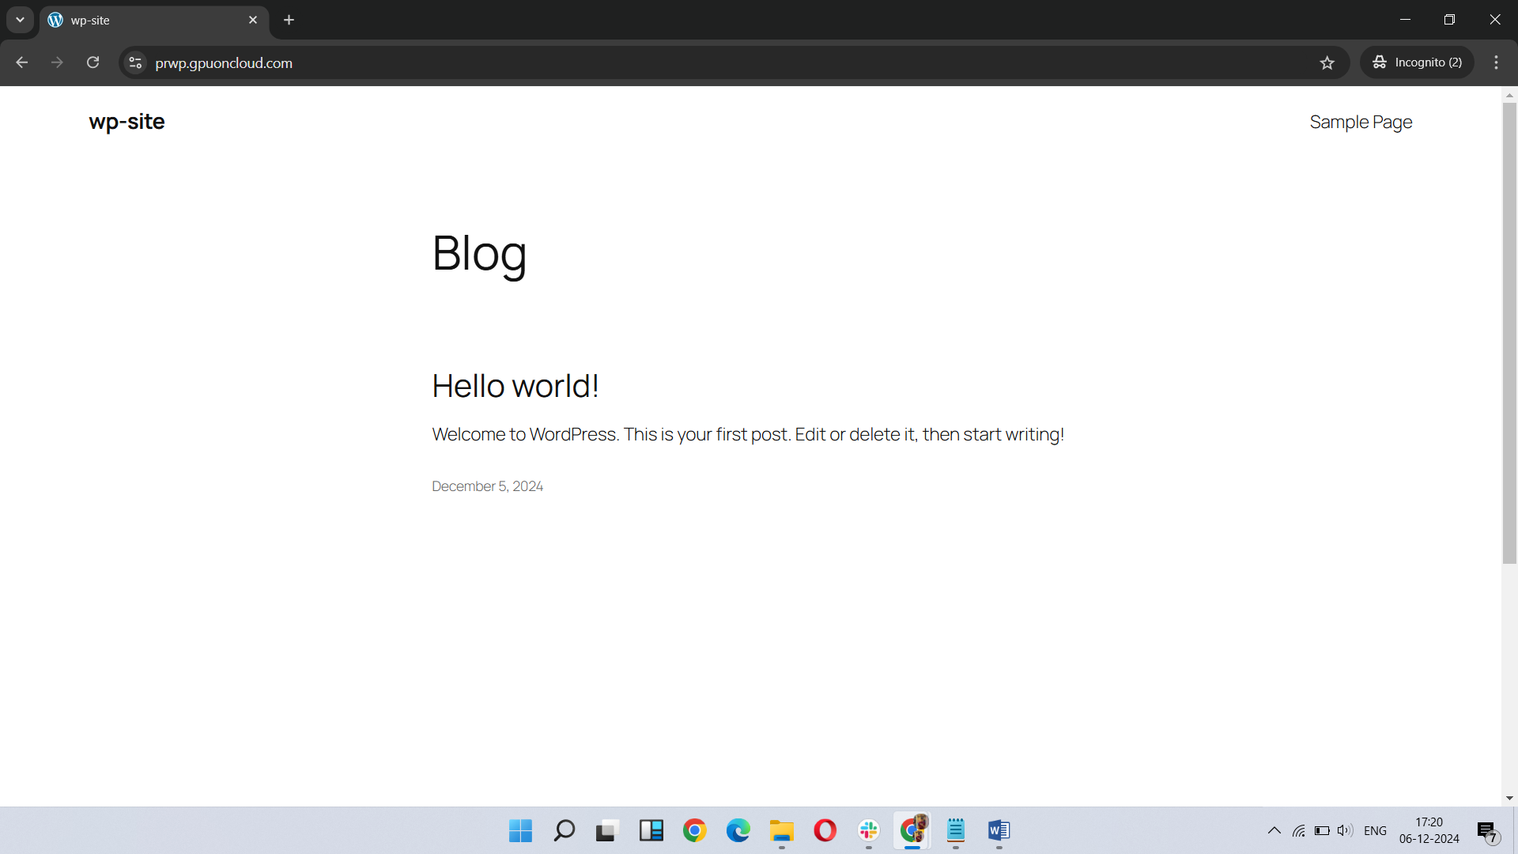 admin page**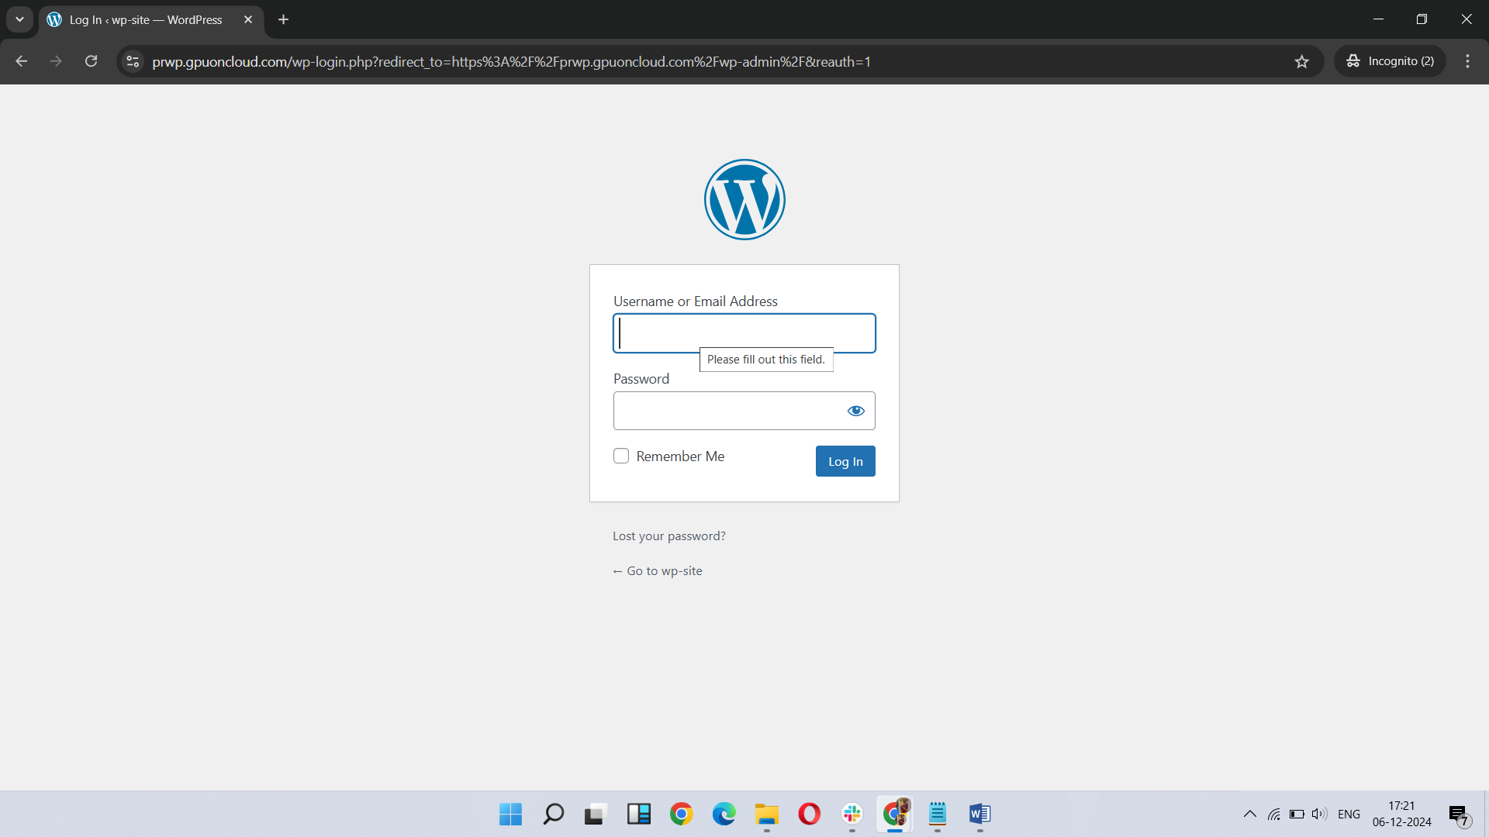

Now Installing Owncloud.  
For installing Owncloud, need compatible version of php   
Creating Database, User and password.  
 mysql -u root –p  
CREATE DATABASE owncloud;

CREATE USER 'ownclouduser'@'localhost' IDENTIFIED BY 'password';

GRANT ALL PRIVILEGES ON owncloud.* TO 'ownclouduser'@'localhost';

FLUSH PRIVILEGES;

EXIT;  
Now installing Owncloud  
cd /var/www/html  
sudo wget <https://download.owncloud.com/server/releases/owncloud-10.0.0.zip>  
unzip owncloud-10.0.0.zip  
Changing Permission the files

sudo chown -R www-data:www-data /var/www/owncloud

sudo chmod -R 755 /var/www/owncloud  
  
Creating and Configuring Apache files

/etc/apache2/sites-available/owncloud.conf  
  
<VirtualHost *:80>

3 ServerAdmin admin@localhost

7 ServerName proc.gpuoncloud.com

9 ServerAlias www.proc.gpuoncloud.com

13 DocumentRoot /var/www/owncloud

17 <Directory /var/www/owncloud>

19 Options +FollowSymlinks

21 AllowOverride All

23 Require all granted

25 </Directory>

29 ErrorLog ${APACHE_LOG_DIR}/owncloud_error.log

31 CustomLog ${APACHE_LOG_DIR}/owncloud_access.log combined  
 32 </VirtualHost>  
  
Enabling Wordpress.conf file while Disabling default page and rewrite module.  
a2ensite owncloud.conf

a2enmod rewrite

Restart Apache for refreshing server  
Restart the apache Server

**Completed Owncloud Installation  
landing page**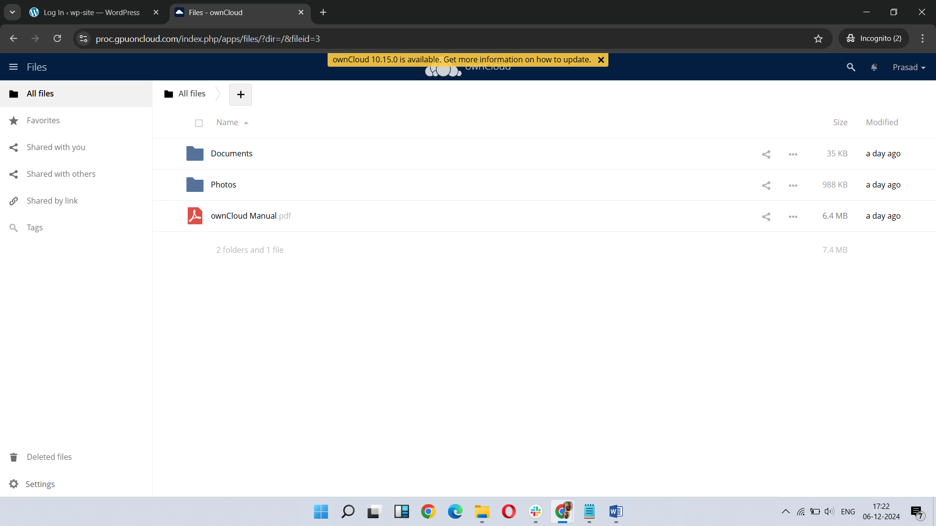mysql -u root –pCreating Database , User and password.  
CREATE DATABASE osticket;

CREATE USER 'osticketuser'@'localhost' IDENTIFIED BY 'password';

GRANT ALL PRIVILEGES ON osticket.* TO 'osticketuser'@'localhost';

FLUSH PRIVILEGES;

EXIT;  
Downloading the Osticket application.  
cd /var/www/  
wget <https://github.com/osTicket/osTicket/releases/download/v1.17.2/osTicket-v1.17.2.zip>

unzip osTicket-v1.17.2.zip -d osticket

Renaming the configuration file.  
 mv ost-sampleconfig.php ost-config.php

Changing Permission the files  
sudo chown -R www-data:www-data /var/wwwosticket

sudo chmod 0666 /var/www/osticket/include/ost-config.php  
  
Configure Apache for osTicket

/etc/apache2/sites-available/osticket.conf

12 <VirtualHost *:443>

13

14 ServerAdmin admin@localhost

15

16 ServerName prot.gpuoncloud.com

17

18 DocumentRoot /var/www/osticket/upload

19

20

21 <Directory /var/www/osticket/upload>

22

23 Options +FollowSymlinks

24

25 AllowOverride All

26

27 Require all granted

28

29 </Directory>

33 ErrorLog ${APACHE_LOG_DIR}/osticket_error.log

34

35 CustomLog ${APACHE_LOG_DIR}/osticket_access.log combined

40 </VirtualHost>

Enabling Wordpress.conf file while Disabling default page and rewrite module.  
  
a2ensite osticket.conf

sudo a2enmod rewrite

Restart Apache for refreshing server  
systemctl restart apache2

**Completed OsTicket Installation  
client page**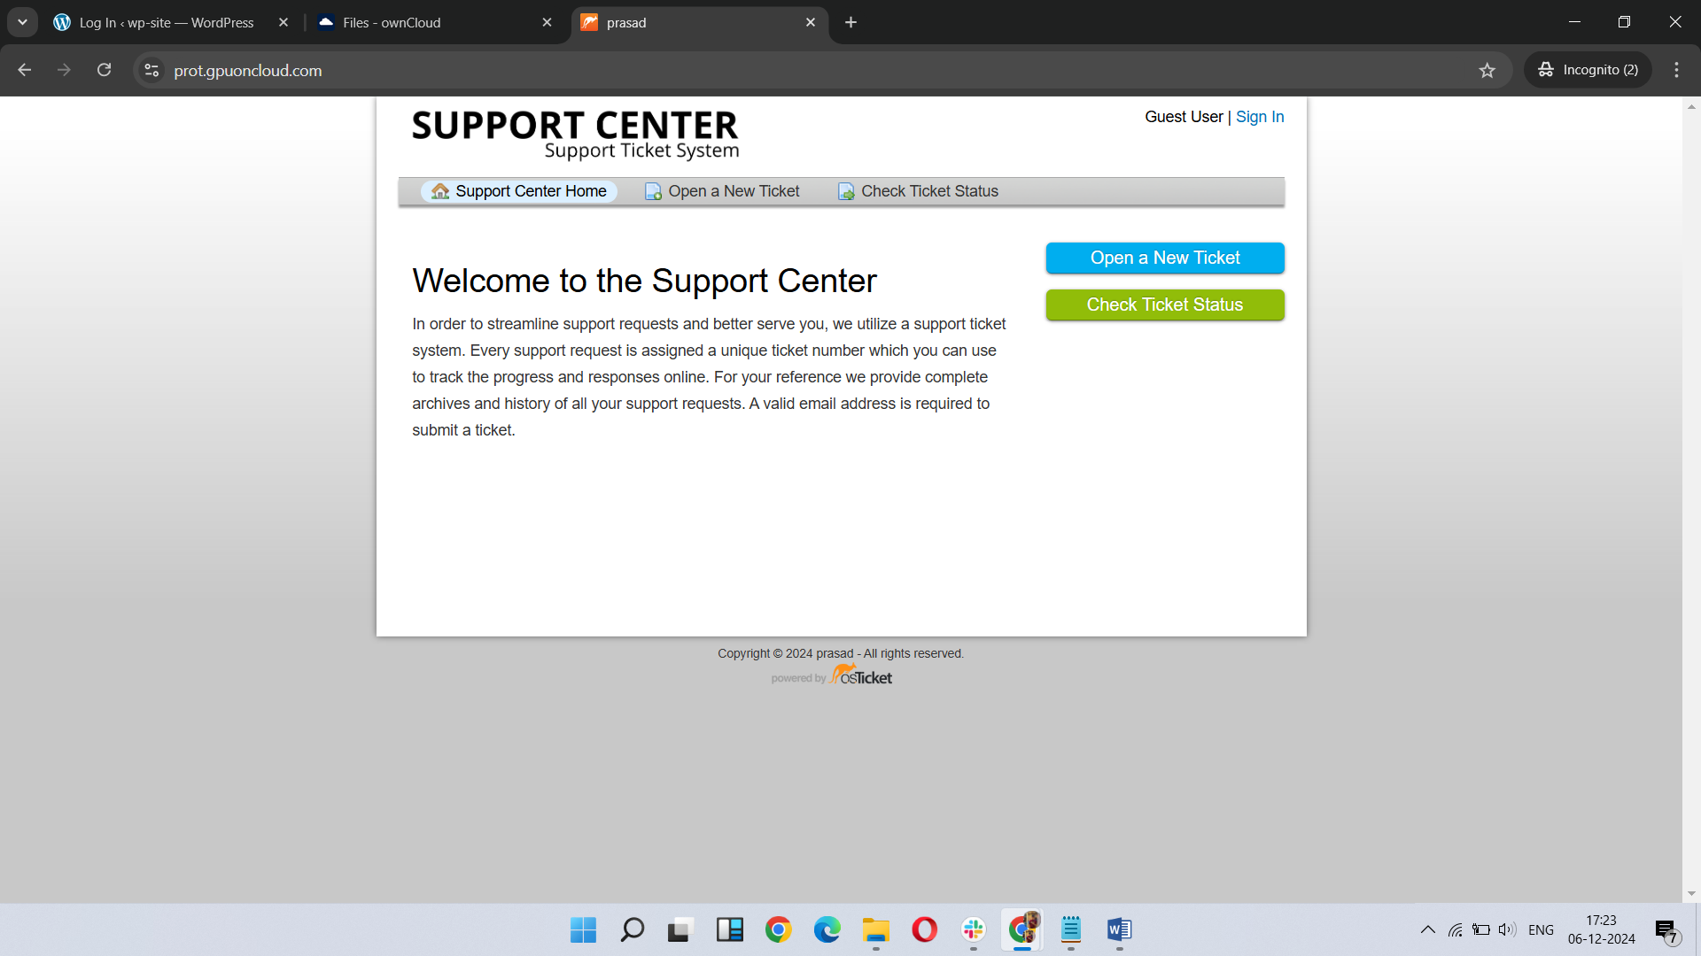

**Admin page**

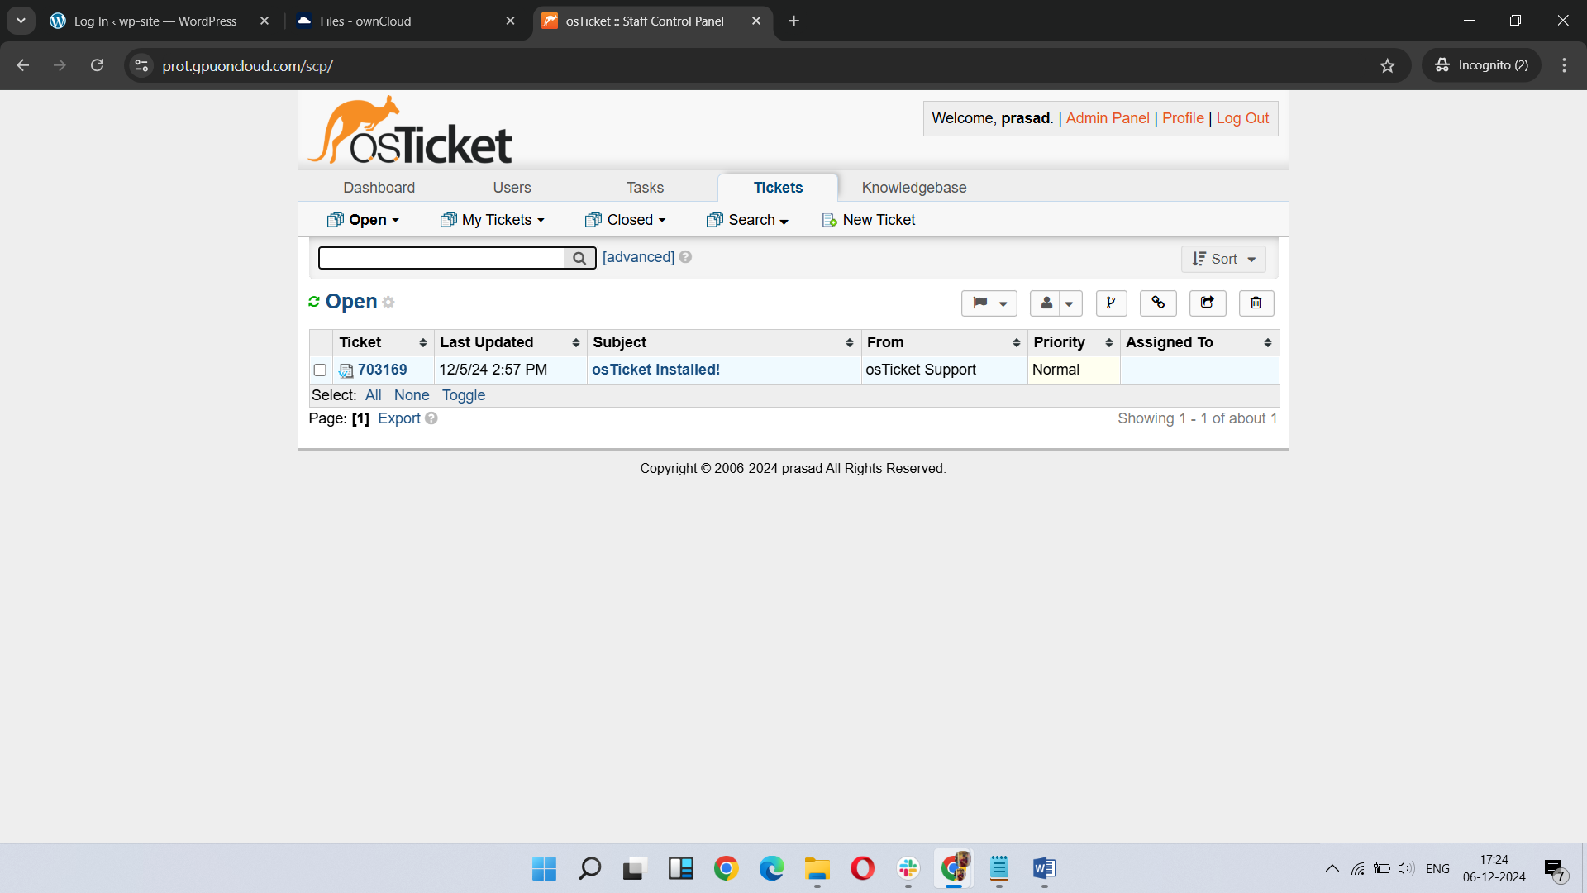 **Errors  
Installing php by this command apt install php-mysql will install latest version of php.  
incompatible php version for owncloud so I downgraded my php to php 7 so it will run smoothly with owncloud 10.**